**Java Project Report**

**Scenario description**

The Java program is intended to be applied in a dairy farm environment and to be used by the farmer to calculate the milk products being generated in the farm. The farmer will have the ability to calculate the sales of his milk products in a daily or weekly basis. The milk products used in this scenario are milk, yoghurt, cheese, ghee, ice cream, butter, skimmed milk, whey and fermented milk.

**Program specifications**

The user is supposed to key in the quantity of sales for each product as the system prompts for values. After the values are entered, the program calculates the value of sales and outputs the results in the console. The results will be a currency value of the sales per product. The products to be included in the program are as follows:-

1. Milk
2. Yoghurt
3. Cheese
4. Ghee
5. Ice cream
6. Butter
7. Skimmed milk
8. Whey
9. Fermented milk

The value of the products will be keyed in by the farmer and finally the program will calculate the total value of sales per the quantity entered by the farmer. The farmer will therefore have to key in the following:-

1. Cost per unit quantity of each product i.e Ghee $30 per kg
2. Quantity of product sold i.e 50kg Ghee

The program will calculate the total sales per product and also sum up for the farmer the total sales made.

**Screen shots and description of the output**

Being a console program, the results are printed out at the console. Below are the included screenshots

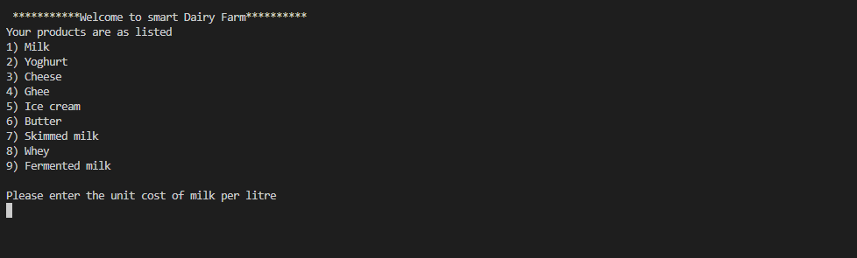

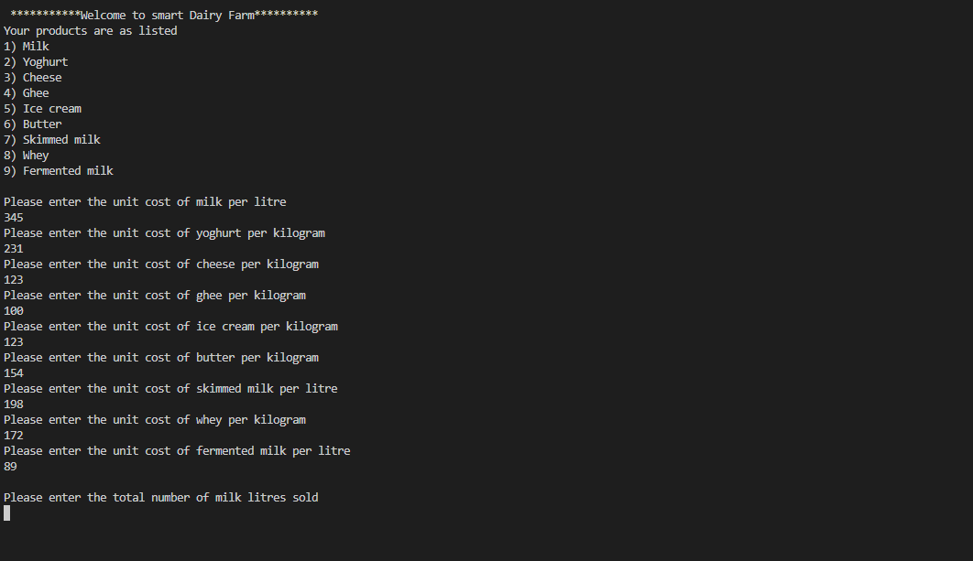

The user inputs the unit cost values after which he is prompted to enter the quantity of sales

On launch console displays the products and prompts user to start entering unit cost values

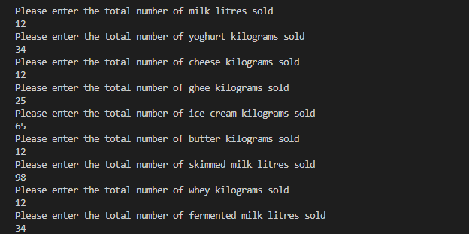

Quantity values of sales are input by the user

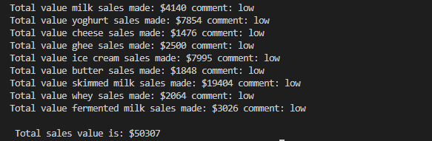

Final results and analysis is printed out where values lower than 5000 receive a “low” comment. The program ends here where all the calculation results are displayed.

**Appendix**

*Project.java*

*import java.util.*;*

*public class Project {*

*/** Variables */*

*/** unit price variables */*

*int uMilkPrice, uYoghurtPrice, uCheesePrice, uGheePrice, uIcreamPrice, uButterPrice, uSmilkPrice, uWheyPrice,*

*uFmilkPrice, totalSales = 0;*

*/** quantitiy variables */*

*int milkQty, yoghurtQty, cheeseQty, gheeQty, iCreamQty, butterQty, sMilkQty, wheyQty, fMilkQty;*

*/** sales variables */*

*int milkSales, yoghurtSales, cheeseSales, gheeSales, iCreamSales, butterSales, sMilkSales, wheySales, fMilkSales;*

*/** comment variables */*

*String milkCmt, yoghurtCmt, cheeseCmt, gheeCmt, iCreamCmt, butterCmt, sMilkCmt, wheyCmt, fMilkCmt;*

*/** Method to initialize the program */*

*public void initProgram() {*

*System.out.println("\n ***********Welcome to smart Dairy Farm**********");*

*System.out.println("Your products are as listed");*

*System.out.println("1) Milk");*

*System.out.println("2) Yoghurt");*

*System.out.println("3) Cheese");*

*System.out.println("4) Ghee");*

*System.out.println("5) Ice cream");*

*System.out.println("6) Butter");*

*System.out.println("7) Skimmed milk");*

*System.out.println("8) Whey");*

*System.out.println("9) Fermented milk");*

*/** collect values */*

*this.collectValues();*

*/** display results */*

*this.displayResults();*

*}*

*/** Collect quantity and unit costs */*

*public void collectValues() {*

*Scanner input = new Scanner(System.in);*

*/** Collect unit cost values */*

*System.out.println("\nPlease enter the unit cost of milk per litre");*

*this.uMilkPrice = input.nextInt();*

*System.out.println("Please enter the unit cost of yoghurt per kilogram");*

*this.uYoghurtPrice = input.nextInt();*

*System.out.println("Please enter the unit cost of cheese per kilogram");*

*this.uCheesePrice = input.nextInt();*

*System.out.println("Please enter the unit cost of ghee per kilogram");*

*this.uGheePrice = input.nextInt();*

*System.out.println("Please enter the unit cost of ice cream per kilogram");*

*this.uIcreamPrice = input.nextInt();*

*System.out.println("Please enter the unit cost of butter per kilogram");*

*this.uButterPrice = input.nextInt();*

*System.out.println("Please enter the unit cost of skimmed milk per litre");*

*this.uSmilkPrice = input.nextInt();*

*System.out.println("Please enter the unit cost of whey per kilogram");*

*this.uWheyPrice = input.nextInt();*

*System.out.println("Please enter the unit cost of fermented milk per litre");*

*this.uFmilkPrice = input.nextInt();*

*/** collect quantity values */*

*System.out.println("\nPlease enter the total number of milk litres sold");*

*this.milkQty = input.nextInt();*

*System.out.println("Please enter the total number of yoghurt kilograms sold");*

*this.yoghurtQty = input.nextInt();*

*System.out.println("Please enter the total number of cheese kilograms sold");*

*this.cheeseQty = input.nextInt();*

*System.out.println("Please enter the total number of ghee kilograms sold");*

*this.gheeQty = input.nextInt();*

*System.out.println("Please enter the total number of ice cream kilograms sold");*

*this.iCreamQty = input.nextInt();*

*System.out.println("Please enter the total number of butter kilograms sold");*

*this.butterQty = input.nextInt();*

*System.out.println("Please enter the total number of skimmed milk litres sold");*

*this.sMilkQty = input.nextInt();*

*System.out.println("Please enter the total number of whey kilograms sold");*

*this.wheyQty = input.nextInt();*

*System.out.println("Please enter the total number of fermented milk litres sold");*

*this.fMilkQty = input.nextInt();*

*}*

*/** Initiate calculation and display the results */*

*public void displayResults() {*

*/** Get sales calculation */*

*this.milkSales = this.calculateSales(milkQty, uMilkPrice);*

*this.yoghurtSales = this.calculateSales(yoghurtQty, uYoghurtPrice);*

*this.cheeseSales = this.calculateSales(cheeseQty, uCheesePrice);*

*this.gheeSales = this.calculateSales(gheeQty, uGheePrice);*

*this.iCreamSales = this.calculateSales(iCreamQty, uIcreamPrice);*

*this.butterSales = this.calculateSales(butterQty, uButterPrice);*

*this.sMilkSales = this.calculateSales(sMilkQty, uSmilkPrice);*

*this.wheySales = this.calculateSales(wheyQty, uWheyPrice);*

*this.fMilkSales = this.calculateSales(fMilkQty, uFmilkPrice);*

*/** get sales comments */*

*this.milkCmt = this.getComment(this.milkSales);*

*this.yoghurtCmt = this.getComment(this.yoghurtSales);*

*this.cheeseCmt = this.getComment(this.cheeseSales);*

*this.gheeCmt = this.getComment(this.gheeSales);*

*this.iCreamCmt = this.getComment(this.iCreamSales);*

*this.butterCmt = this.getComment(this.butterSales);*

*this.sMilkCmt = this.getComment(this.sMilkSales);*

*this.wheyCmt = this.getComment(this.wheySales);*

*this.fMilkCmt = this.getComment(this.fMilkSales);*

*/** get total sales */*

*this.totalSales = this.calcTotal();*

*/** display results */*

*System.out.println("Total value milk sales made: $" + this.milkSales + " comment: " + milkCmt);*

*System.out.println("Total value yoghurt sales made: $" + this.yoghurtSales + " comment: " + yoghurtCmt);*

*System.out.println("Total value cheese sales made: $" + this.cheeseSales + " comment: " + cheeseCmt);*

*System.out.println("Total value ghee sales made: $" + this.gheeSales + " comment: " + gheeCmt);*

*System.out.println("Total value ice cream sales made: $" + this.iCreamSales + " comment: " + iCreamCmt);*

*System.out.println("Total value butter sales made: $" + this.butterSales + " comment: " + butterCmt);*

*System.out.println("Total value skimmed milk sales made: $" + this.sMilkSales + " comment: " + sMilkCmt);*

*System.out.println("Total value whey sales made: $" + this.wheySales + " comment: " + wheyCmt);*

*System.out.println("Total value fermented milk sales made: $" + this.fMilkSales + " comment: " + fMilkCmt);*

*System.out.println("\n Total sales value is: $" + this.totalSales);*

*}*

*/** Comment on prices */*

*public String getComment(int value) {*

*String comment = "";*

*/** commenting sales status as low, moderate or impressively high */*

*if (this.milkSales > 20000) {*

*comment = "Impressively high!";*

*} else if (this.milkSales > 5000) {*

*comment = "moderate";*

*} else {*

*comment = "low";*

*}*

*return comment;*

*}*

*/** calculate sales */*

*public int calculateSales(int quantity, int price) {*

*return quantity * price;*

*}*

*/** calculate total sales */*

*public int calcTotal() {*

*return this.milkSales + this.yoghurtSales + this.cheeseSales + this.gheeSales + this.iCreamSales*

*+ this.butterSales + this.sMilkSales + this.wheySales + this.fMilkSales;*

*}*

*/** Run the code from here */*

*public static void main(String[] args) {*

*Project project = new Project();*

*project.initProgram();*

*}*

*}*